**SuperSet Id: 6376594**

React(Hands-On)

**Exercise-1:**

App.js Code:

import React from 'react';

function App() {

  return (

    <div>

      <h1>Welcome the first session of React</h1>

    </div>

  );

}

export default App;

Output:

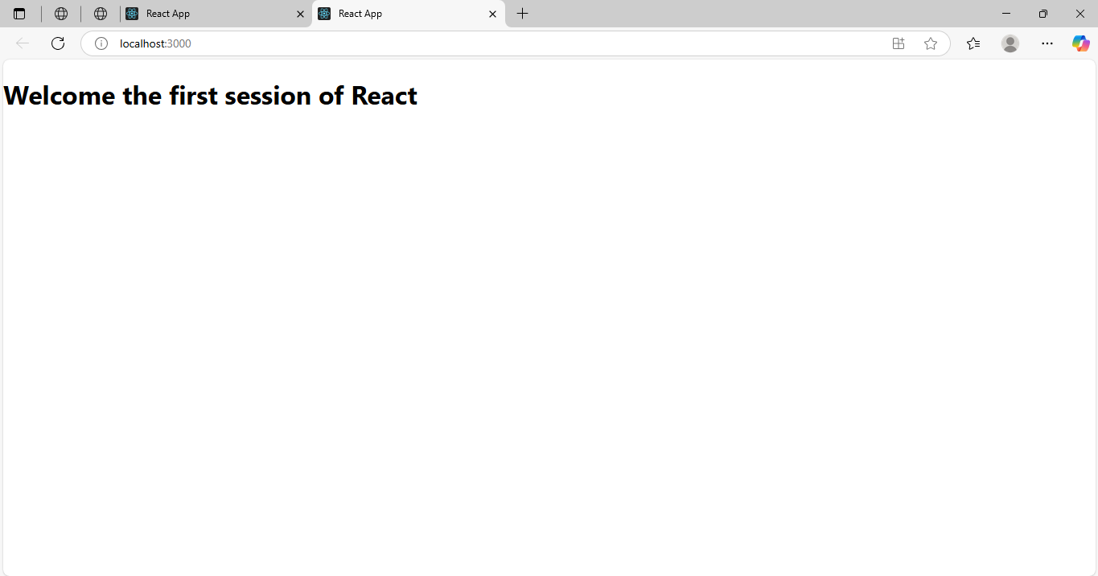

**Exercise-2:**

Home.js Code:

import React from 'react';

function Home() {

  return (

    <div>

      <h2>Welcome to the Home Page of Student Management Portal</h2>

    </div>

  );

}

export default Home;

About.js Code:

import React from 'react';

function About() {

  return (

    <div>

      <h2>Welcome to the About Page of Student Management Portal</h2>

    </div>

  );

}

export default About;

Contact.js Code:

import React from 'react';

function Contact() {

  return (

    <div>

      <h2>Welcome to the Contact Page of Student Management Portal</h2>

    </div>

  );

}

export default Contact;

App.js Code:

import React from 'react';

import Home from './Components/Home';

import About from './Components/About';

import Contact from './Components/Contact';

function App() {

  return (

    <div className="App">

      <Home />

      <About />

      <Contact />

    </div>

  );

}

export default App;

Output:

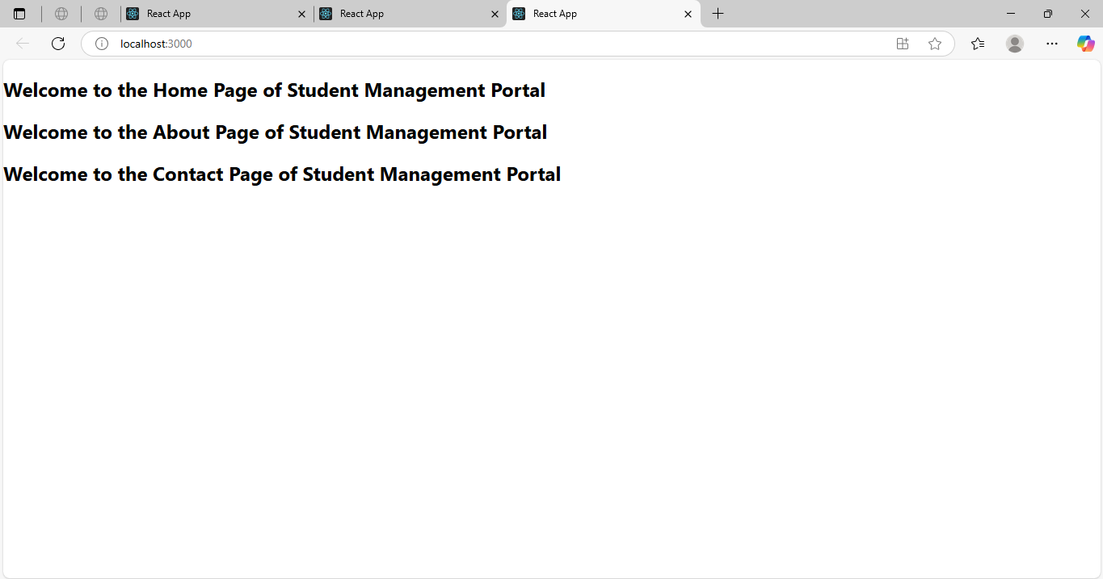

**Exercise-3:**

CalculatorScore.js Code:

import '../stylesheets/mystyle.css';

const percentToDecimal = (decimal) => {

  return (decimal.toFixed(2) + '%');

};

const calcScore = (total, goal) => {

  return percentToDecimal(total / goal);

};

export const CalculateScore = ({ Name, School, total, goal }) => (

  <div className="formatstyle">

    <h1><font color="Brown">Student Details:</font></h1>

    <div className="Name">

      <b><span>Name:</span></b>

      <span> {Name}</span>

    </div>

    <div className="School">

      <b><span>School:</span></b>

      <span> {School}</span>

    </div>

    <div className="Total">

      <b><span>Total:</span></b>

      <span>{total}</span>Marks

    </div>

    <div className="Score">

      <b>Score:</b>

      <span>{calcScore(total, goal)}</span>

    </div>

  </div>

);

mystyle.css Code:

.Name {

  font-weight: 300;

  color: blue;

}

.School {

  color: crimson;

}

.Total {

  color: darkmagenta;

}

.formatstyle {

  text-align: center;

  font-size: large;

}

.Score {

  color: forestgreen;

}

App.js Code:

import { CalculateScore } from './components/CalculateScore';

function App() {

  return (

    <div>

      <CalculateScore

        Name={"Steeve"}

        School={"DNV Public School"}

        total={284}

        goal={3}

      />

    </div>

  );

}

export default App;

Output:

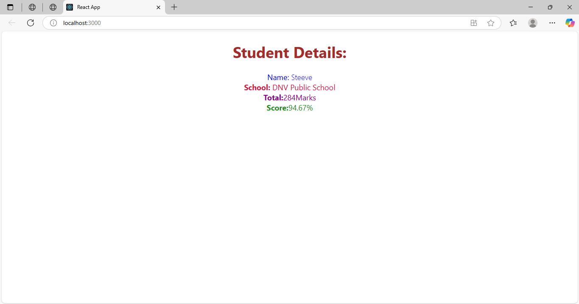

**Exercise-4:**

Post.js Code:

import React from 'react';

function Post({ title, body }) {

  return (

    <div style={{ border: "1px solid grey", margin: "10px", padding: "10px" }}>

      <h2>{title}</h2>

      <p>{body}</p>

    </div>

  );

}

export default Post;

Posts.js Code:

import React, { Component } from 'react';

import Post from './Post';

class Posts extends Component {

  constructor(props) {

    super(props);

    this.state = {

      posts: [],

      error: null

    };

  }

  loadPosts = () => {

    fetch('https://jsonplaceholder.typicode.com/posts')

      .then((response) => response.json())

      .then((data) => this.setState({ posts: data }))

      .catch((error) => {

        this.setState({ error });

        throw error;

      });

  }

  componentDidMount() {

    this.loadPosts();

  }

  componentDidCatch(error, info) {

    alert('An error occurred: ' + error.message);

  }

  render() {

    return (

      <div>

        <h1>Blog Posts</h1>

        {this.state.posts.map((post) => (

          <Post key={post.id} title={post.title} body={post.body} />

        ))}

      </div>

    );

  }

}

export default Posts;

App.js Code:

import React from 'react';

import Posts from './Posts';

function App() {

  return (

    <div className="App">

      <Posts />

    </div>

  );

}

export default App;

Output:

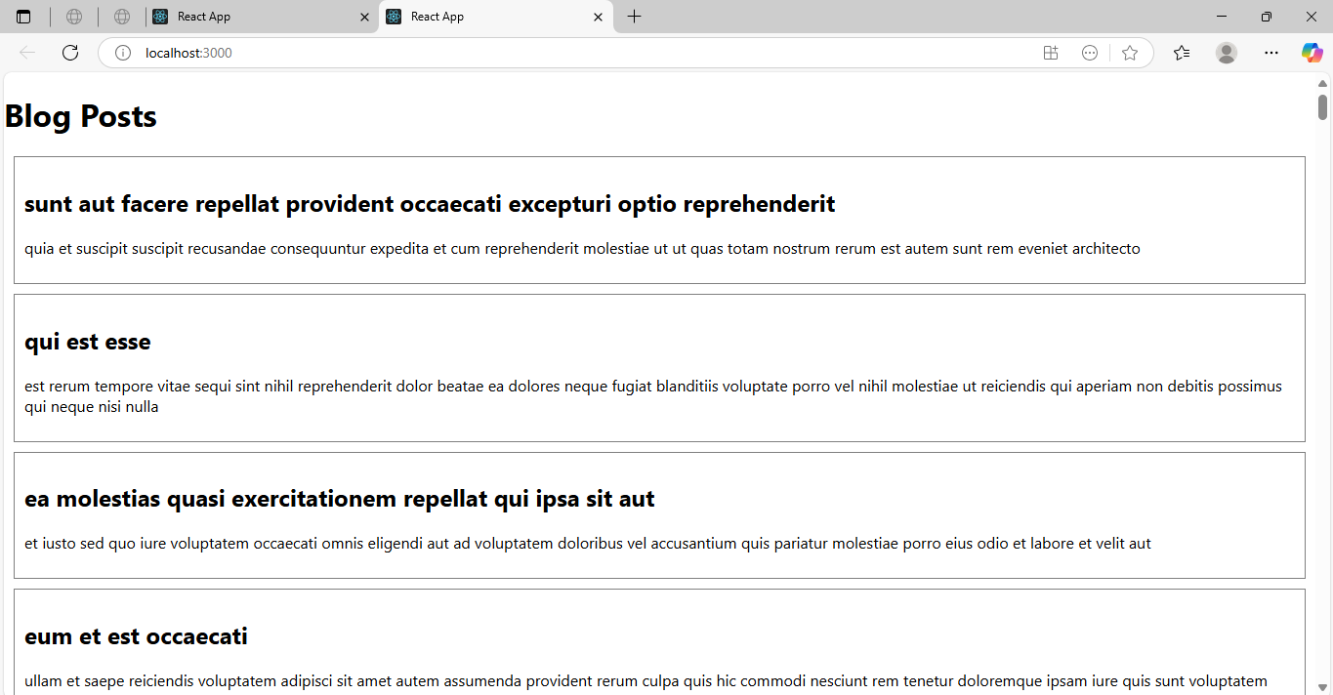

**Exercise-5:**

CohortDetails.js Code:

import React from 'react';

import styles from './CohortDetails.module.css';

function CohortDetails({ name, startDate, status }) {

  const statusStyle = {

    color: status === 'ongoing' ? 'green' : 'blue'

  };

  return (

    <div className={styles.box}>

      <dl>

        <dt>Cohort Name:</dt>

        <dd>{name}</dd>

        <dt>Start Date:</dt>

        <dd>{startDate}</dd>

        <dt>Status:</dt>

        <dd><h3 style={statusStyle}>{status}</h3></dd>

      </dl>

    </div>

  );

}

export default CohortDetails;

CohortDetails.module.css Code:

.box {

  width: 300px;

  display: inline-block;

  margin: 10px;

  padding: 10px 20px;

  border: 1px solid black;

  border-radius: 10px;

}

dt {

  font-weight: 500;

}

App.js Code:

import React from 'react';

import CohortDetails from './CohortDetails';

function App() {

  return (

    <div className="App">

      <h1>My Academy Cohort Dashboard</h1>

      <CohortDetails

        name="React Bootcamp"

        startDate="01-July-2025"

        status="ongoing"

      />

      <CohortDetails

        name="Angular Mastery"

        startDate="01-June-2025"

        status="completed"

      />

    </div>

  );

}

export default App;

Output:

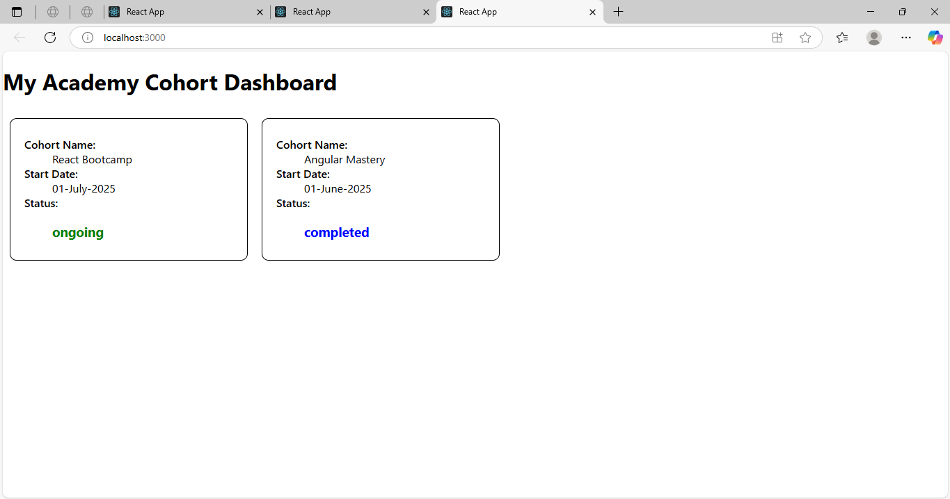

**Additional Exercises:**

**Exercise-6:**

App.js Code:

// src/App.js

import { BrowserRouter, Routes, Route, Link } from 'react-router-dom';

import Home from './Home';

import TrainersList from './TrainersList';

import TrainerDetails from './TrainerDetails';

import trainerData from './TrainersMock';

function App() {

  return (

    <BrowserRouter>

      <div>

        <h1>Trainers Application</h1>

        <nav>

          <Link to="/">Home</Link> | <Link to="/trainers">Trainers List</Link>

        </nav>

        <hr />

        <Routes>

          <Route path="/" element={<Home />} />

          <Route path="/trainers" element={<TrainersList data={trainerData} />} />

          <Route path="/trainers/:id" element={<TrainerDetails />} />

        </Routes>

      </div>

    </BrowserRouter>

  );

}

export default App;

Trainer.js Code:

// src/Trainer.js

class Trainer {

  constructor(trainerId, name, email, phone, technology, skills) {

    this.trainerId = trainerId;

    this.name = name;

    this.email = email;

    this.phone = phone;

    this.technology = technology;

    this.skills = skills;

  }

}

export default Trainer;

TrainerDetails.js Code:

// src/TrainerDetails.js

import { useParams } from 'react-router-dom';

import trainerData from './TrainersMock';

function TrainerDetails() {

  const { id } = useParams();

  const trainer = trainerData.find(t => t.trainerId === parseInt(id));

  if (!trainer) return <p>Trainer not found.</p>;

  return (

    <div>

      <h2>{trainer.name}'s Details</h2>

      <p><strong>Email:</strong> {trainer.email}</p>

      <p><strong>Phone:</strong> {trainer.phone}</p>

      <p><strong>Technology:</strong> {trainer.technology}</p>

      <p><strong>Skills:</strong> {trainer.skills.join(', ')}</p>

    </div>

  );

}

export default TrainerDetails;

TrainersList.js Code:

// src/TrainersList.js

import { Link } from 'react-router-dom';

function TrainersList({ data }) {

  return (

    <div>

      <h2>Trainers List</h2>

      <ul>

        {data.map((trainer) => (

          <li key={trainer.trainerId}>

            <Link to={`/trainers/${trainer.trainerId}`}>{trainer.name}</Link>

          </li>

        ))}

      </ul>

    </div>

  );

}

export default TrainersList;

TrainersMock.js Code:

// src/TrainersMock.js

import Trainer from './Trainer';

const trainerData = [

  new Trainer(1, 'Alice', 'alice@example.com', '1234567890', 'React', ['JS', 'React', 'Redux']),

  new Trainer(2, 'Bob', 'bob@example.com', '2345678901', 'Angular', ['JS', 'Angular', 'RxJS']),

  new Trainer(3, 'Charlie', 'charlie@example.com', '3456789012', 'Vue', ['JS', 'Vue', 'Vuex']),

];

export default trainerData;

Output:

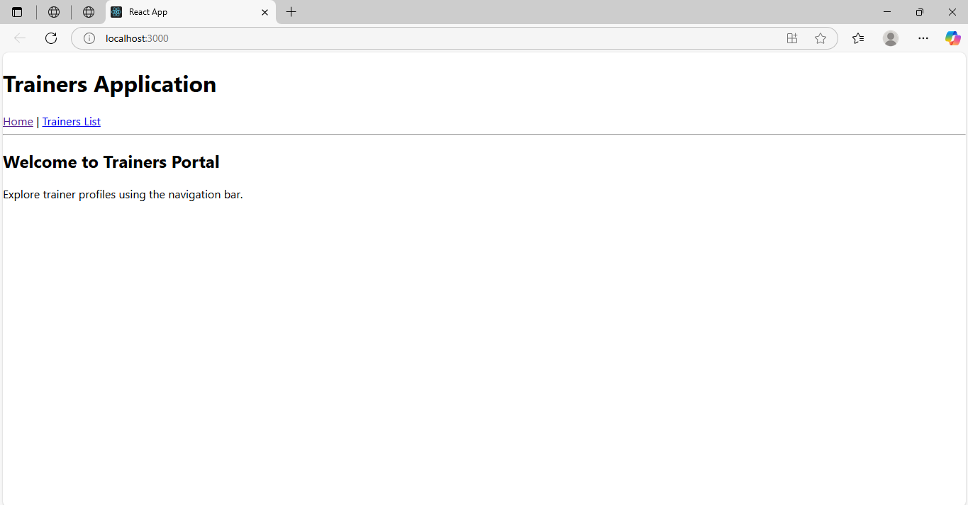

**Exercise-7:**

App.js Code:

// src/App.js

import React from 'react';

import './App.css';

class Cart extends React.Component {

  render() {

    return (

      <div style={{ marginBottom: '10px' }}>

        <h3>Item: {this.props.itemname}</h3>

        <p>Price: ₹{this.props.price}</p>

      </div>

    );

  }

}

class OnlineShopping extends React.Component {

  render() {

    const items = [

      { itemname: "Shoes", price: 1200 },

      { itemname: "T-shirt", price: 800 },

      { itemname: "Watch", price: 2500 },

      { itemname: "Backpack", price: 1500 },

      { itemname: "Sunglasses", price: 1000 },

    ];

    return (

      <div className="App">

        <h2>Welcome to Online Shopping</h2>

        {items.map((item, index) => (

          <Cart key={index} itemname={item.itemname} price={item.price} />

        ))}

      </div>

    );

  }

}

export default OnlineShopping;

App.css Code:

/* src/App.css */

.App {

  text-align: center;

  padding: 20px;

  font-family: Arial, sans-serif;

}

Index.js Code:

// src/index.js

import React from 'react';

import ReactDOM from 'react-dom/client';

import './index.css';

import OnlineShopping from './App';

const root = ReactDOM.createRoot(document.getElementById('root'));

root.render(<OnlineShopping />);

Output:

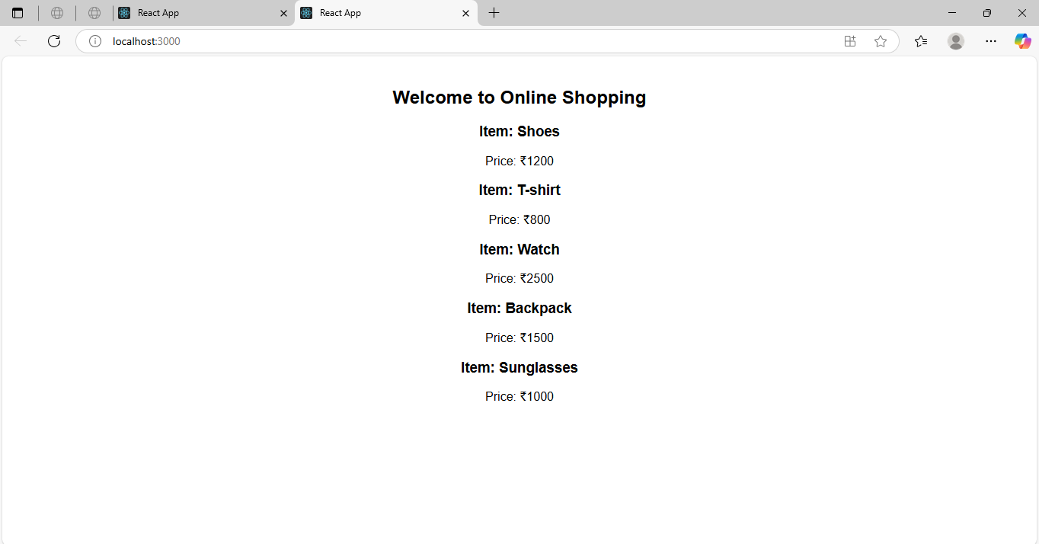

**Exercise-8:**

App.js Code:

// src/App.js

import React from 'react';

import './App.css';

class CountPeople extends React.Component {

  constructor(props) {

    super(props);

    this.state = {

      entryCount: 0,

      exitCount: 0

    };

  }

  updateEntry = () => {

    this.setState({ entryCount: this.state.entryCount + 1 });

  }

  updateExit = () => {

    this.setState({ exitCount: this.state.exitCount + 1 });

  }

  render() {

    return (

      <div className="App">

        <h2>Welcome to the Mall</h2>

        <p>Number of People Entered: {this.state.entryCount}</p>

        <p>Number of People Exited: {this.state.exitCount}</p>

        <button onClick={this.updateEntry}>Login</button>

        <button onClick={this.updateExit} style={{ marginLeft: "10px" }}>Exit</button>

      </div>

    );

  }

}

export default CountPeople;

App.css Code:

/* src/App.css */

.App {

  text-align: center;

  padding: 30px;

  font-family: Arial, sans-serif;

}

button {

  padding: 10px 20px;

  font-size: 16px;

}

Index.js Code:

// src/index.js

import React from 'react';

import ReactDOM from 'react-dom/client';

import './index.css';

import CountPeople from './App';

const root = ReactDOM.createRoot(document.getElementById('root'));

root.render(<CountPeople />);

Output:

